**A prediction model for profit of 50 start-ups data**.

**Y predicted Plot**

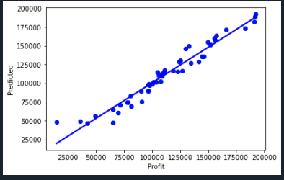

**Mean square error: 78417126.019**

**R square: 95.075**

**OLS Regression Results**

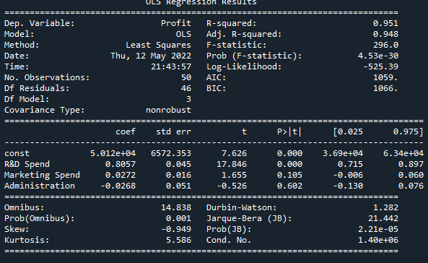

**Variance Inflation Factor**

